ROOF DETECTION GUIDE

# I - CONTEXT

Building footprint layers are useful in preparing base maps and analysis workflows for urban planning and development. They also have use in WASH, change detection, infrastructure planning, and a variety of other applications.

Digitizing building footprints from imagery is a time-consuming task and is commonly done by digitizing features manually. Deep learning models are highly capable of learning these complex semantics and can produce superior results.

Use the deep learning model to automate the tedious manual process of extracting building footprints reduces the time and effort required.

# II - OBJECT

The object of our studies is to estimate the number of potential beneficiaries by multiplying the number of roofs with the average household size.

The main factor is the number of roofs, the automatic counting/detection of this number is covered in this document

# III – EXISTING DATA – METHODOLOGIES AND TEST

The following sections describe the different steps and data we used in the search for the optimal methods and tools to count the number of roofs

## A - Using Google Ai: open footprint building data

The dataset contains 516M building detections, across an area of 19.4M km2 (64% of the African continent).

For each building in this dataset, each polygon describes its footprint on the ground, a confidence score indicating how sure we are that this is a building, and a [Plus Code](https://plus.codes/) corresponding to the center of the building. There is no information about the type of building, its street address, or any details other than its geometry.

Process

Delineation of the intervention are in ArcGIS pro

Manual adjustments if needed

Extraction of the building footprint from the area of interest

Conversion in ArcGISpro or pgsql2shp

Download of the building footprint in **[Open building footprint](https://sites.research.google/open-buildings/)**

Inputs

* Csv file extracted from the open building footprint
* Software: ArcGIS Pro
* Tools: Convert XY table to point to get the building centroid
* Python code to get the building footprint

Result

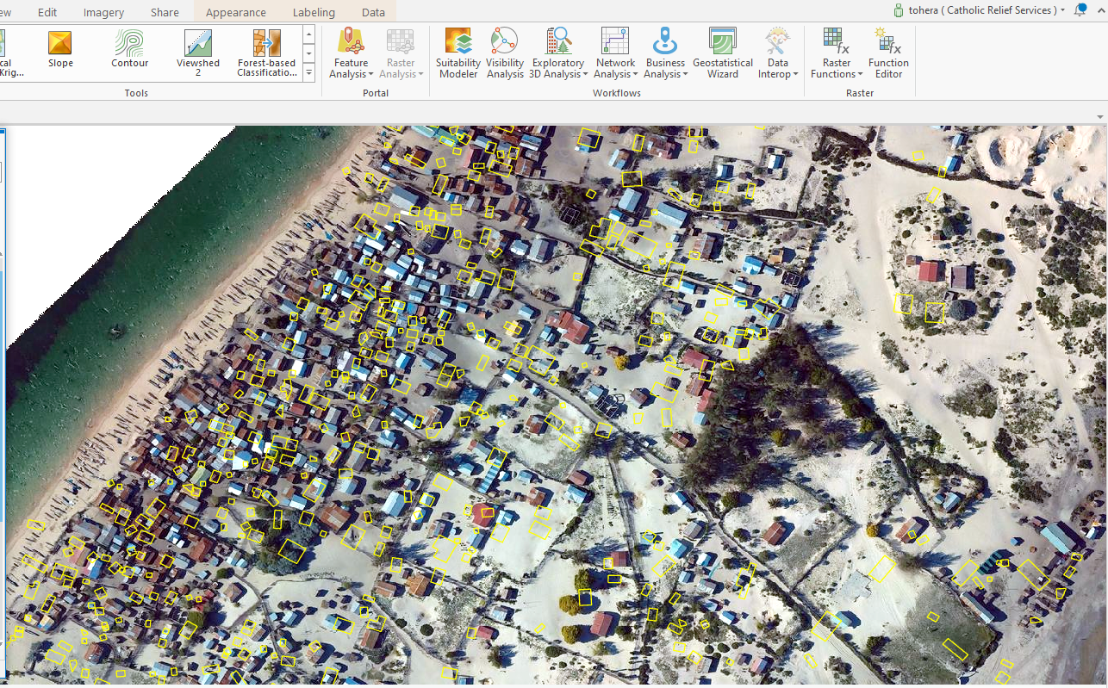

Accuracy

Precision is good in terms of detection, but some adjustments are necessary for some objects

## B – Use of ESRI Living Atlas World View (Clarity)

However, in the lack of high-resolution satellite or drone images, the use of ESRI Living Atlas World View (Clarity) could also be considered, but the accuracy is not as good as that obtained by high resolution images

Process

Delineation of the intervention area in ArcGIS pro

Detect Object using deep learning

Train deep learning model

Add the World View (clarity) from ArcGIS Living Atlas

Delineate and extract the area of interest from World View (clarity)

Create and managed labeled object (Label object for Deep learning)

Export training data for deep learning

Inputs

8-bit, 3-band imagery of the area of interest through world view (Clarity)

Output  
Feature class containing building footprints

Applicable geographies  
The model is expected to work on areas where the images are up to date

Model architecture

The model uses the [FastRCNN](https://developers.arcgis.com/python/guide/how-maskrcnn-works/" \t "_blank) model architecture implemented using ArcGIS API for Python.

Result

Accuracy

## C – Use of Deep Learning Building Footprint Extraction - Africa

This deep learning model is used to extract building footprints from high-resolution (10–40 cm) imagery.

Process

Delineation of the intervention are in ArcGIS pro

Download the [building footprint extraction – Africa model](https://www.arcgis.com/home/item.html?id=979cb0cf938946bfb8bb2f41cf9f9795)

Detect Object using deep learning

Manual adjustments if needed

Using the model

To use this model, ensure that the supported deep learning libraries are installed. For more details, check [Deep Learning Libraries Installer for ArcGIS](https://github.com/esri/deep-learning-frameworks). Follow the guide [here](https://deldev.maps.arcgis.com/sharing/rest/content/items/91ed0eb83e4948c0950a8de9b2ebd5fb/data) to use the model.  
  
Note: Deep learning is computationally intensive, and a powerful GPU is recommended to process large datasets.

Inputs

8-bit, 3-band high-resolution (10–40 cm) imagery

Output

Feature class containing building footprints

Applicable geographies

The model is expected to work in Africa and gives the best results in Uganda and Tanzania.

Model architecture

The model uses the [MaskRCNN](https://developers.arcgis.com/python/guide/how-maskrcnn-works/" \t "_blank) model architecture implemented using ArcGIS API for Python.

Result

Accuracy

The accuracy depends on the area of interest, in this example, the accuracy is not good, but it gives the best results in Uganda and Tanzania.

## D – Use of deep learning customized model

This deep learning model is used to extract building footprints from high-resolution (10–40 cm) imagery.

Using the model

To use this model, ensure that the supported deep learning libraries are installed. Just prepare the Inputs mentioned in this model builder

Inputs

8-bit, 3-band high-resolution (10–40 cm) imagery

Output

Feature class containing building footprints

Model architecture

The model uses the [MaskRCNN](https://developers.arcgis.com/python/guide/how-maskrcnn-works/" \t "_blank) model architecture implemented using ArcGIS API for Python.

Result

Accuracy

